**June 27th 2010**

**Session B, Week 1**

Creative Minds of Highlander

# Glass In the Bead Shack

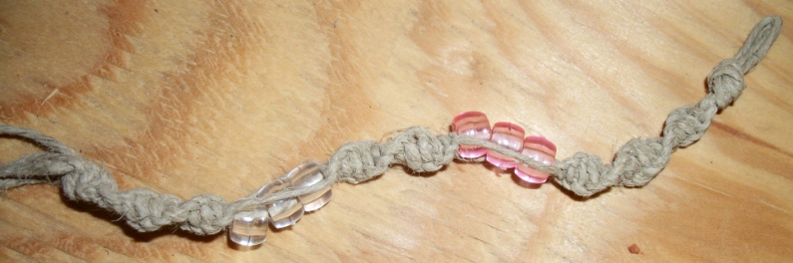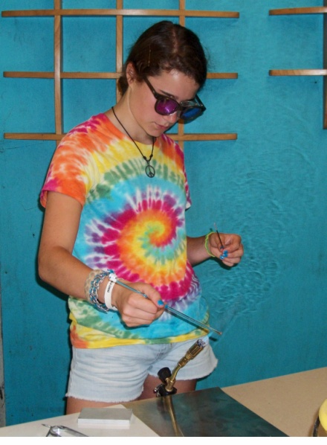

If you would like your artwork exhibited in next week’s BLT please see Bryan Beck to have photo’s taken.

**Logan Gobert –** Cabin 9

Logan made a very unique pink and clear hemp bracelet on Tuesday

**Rael Watner** – Cabin 22

Rael spent his second period on Wednesday at the Bead Shack making one of the most original Light Catchers I have seen in a long time.

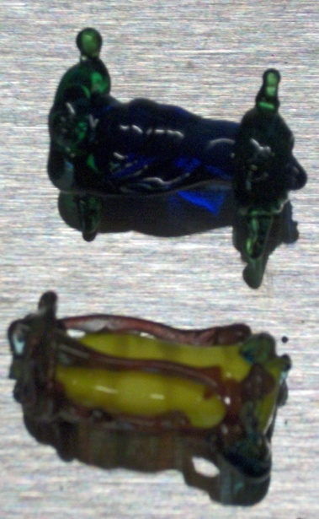

**Robert Stephan** – Cabin 22

Robert was the first one to use the new torches and pump out some really cool one-of-a-kind beads on Campers Choice Day!!

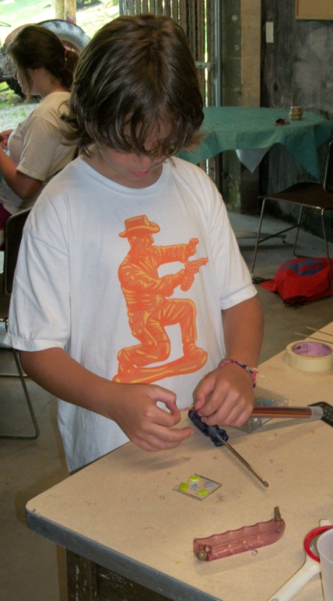

***Glass Announcements***

* Make Light Catchers and Mosaic Boxes every Campers Choice
* Remember only two campers a period can make beads and you must wear close toed shoes

**Emily Greenberg** – Cabin 3

Emily also made some beads of her own.

**June 27th 2010**

**Session B, Week 1**

Creative Minds of Highlander

# Wood Working with Richard

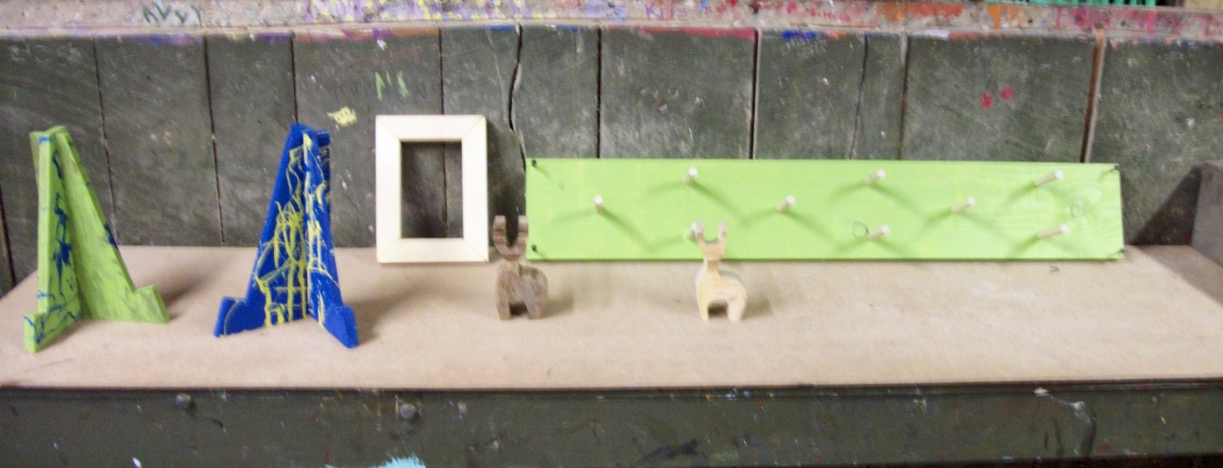

***Painting*** ***Announcements***

* Sign up for Campers choice to paint your crazy creeks!!
* And come in for some awesome spin art…. It’s fun for everyone

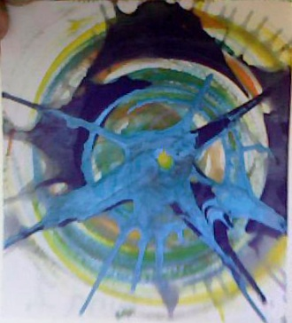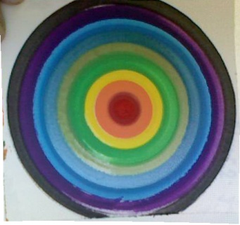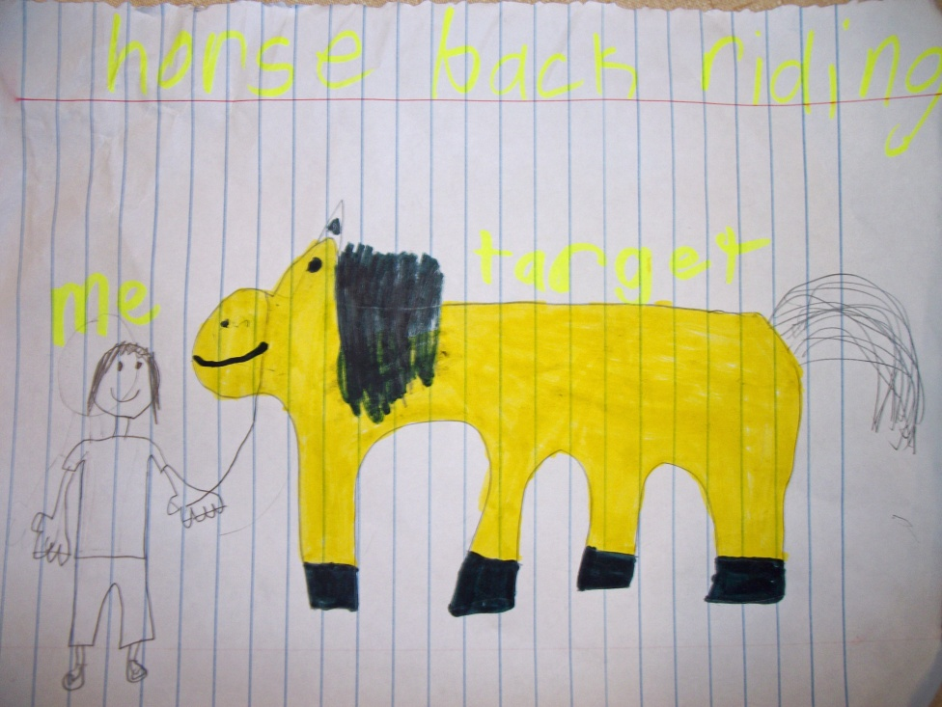

**Marilyn Threlkeld** – Cabin 17

Marilyn drew this picture of her and Target at Horseback Riding. This girl definitely has the “Artists’ Gift” in her!!

Art from the BLT Headquarters with Molly

There is plenty of wood at the Wood Shop for you to make your picture frames, wooden deer, hangers, and many more cool items!!! So make sure to sign up for Camper Choice.

**June 27th 2010**

**Session B, Week 1**

Creative Minds of Highlander

# Spinning Wheels at the Pottery Barn with Nathan

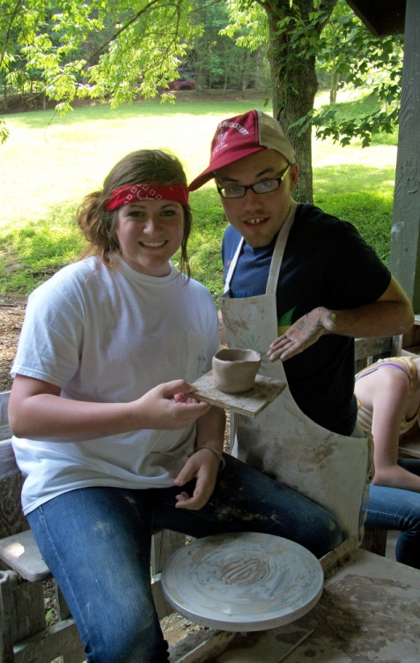

**Sophie Cabaniss** – Cabin 2

Friday Sophie and Nathan posed for a picture for me at the Pottery Barn to show off her new bowl.

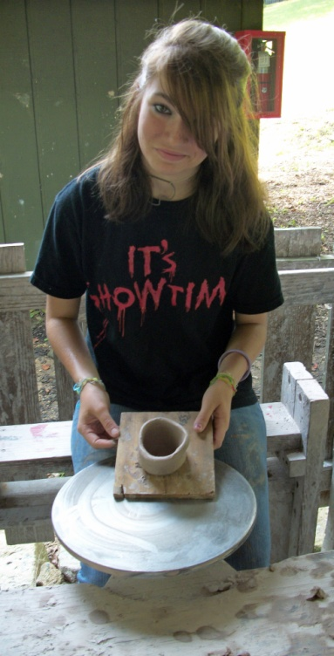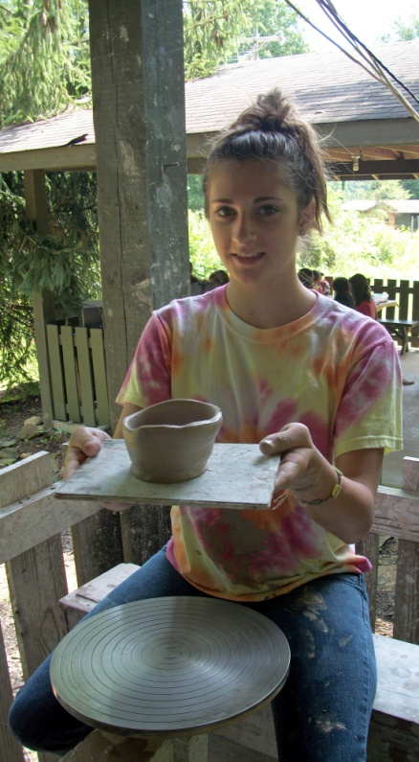

***Pottery Announcements***

* Come Tuesday to glaze any pottery you made this past week.

**Megan Mulhall** – Cabin 2

Megan is a natural behind the pottery wheel. Just look at her craftsmanship.

**Gigi** **–** Cabin 2

Gigi worked for hours putting sweat and tears into this beautiful bowl… I cannot wait to see how she glazes it.

**June 27th 2010**

**Session B, Week 1**

Creative Minds of Highlander

# Capturing Camp Memories with Emily

**Cabin 12**

We all see them running around camp searching for the perfect shot, seeking out colors and shapes. But what do they do with the photos when they get back to the photo lab?

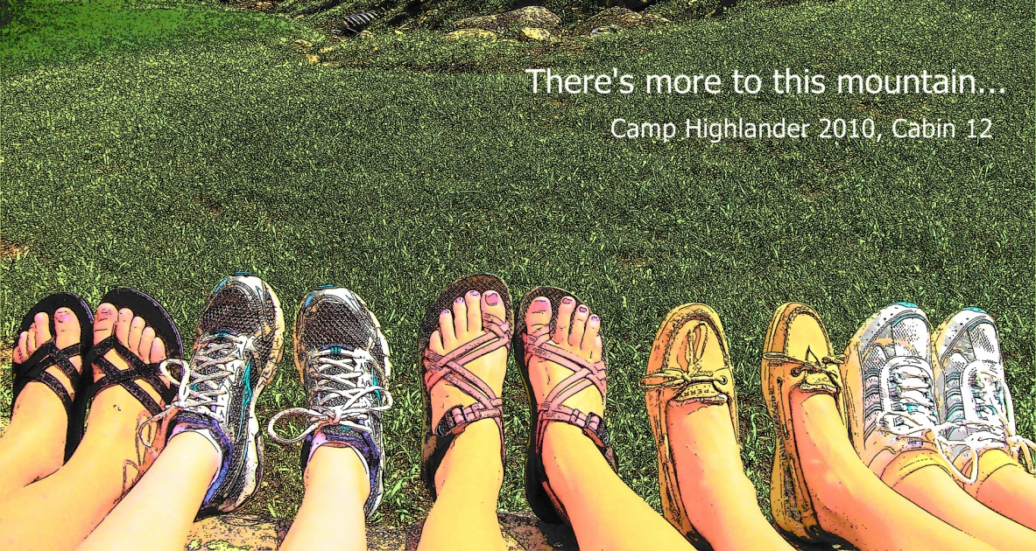

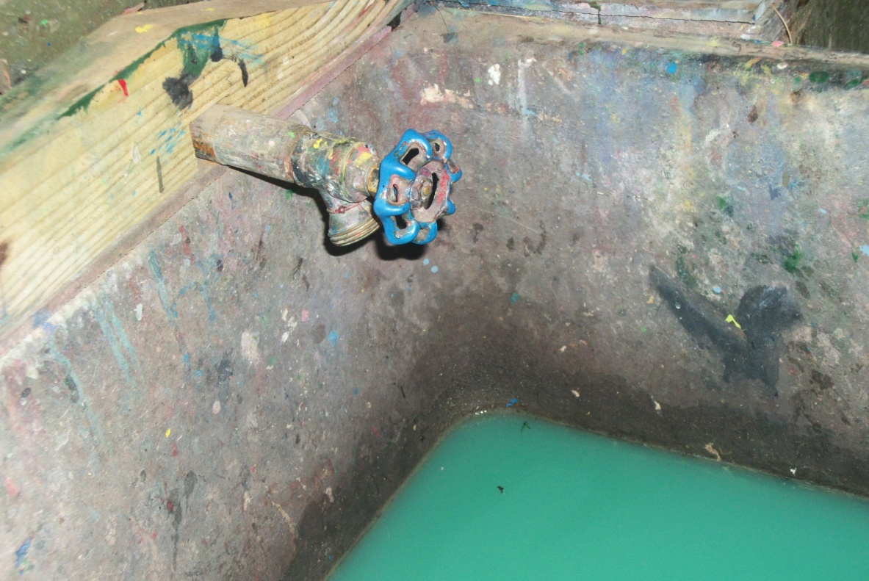

**Cabin 10**

You can always find beauty in even some of the messiest areas